Meeting Notes

Feb 12, 2025 | Leg database run through guttmacher
Attendees: Frydamfairbanks@guttmacher.orgtcurhan@guttmacher.org

Notes
- Tracking this meeting here: ​Tracker - Workflow Design

Action items

Feb 6, 2025 | State Leg Overhaul
Attendees: Candace Gibson <cgibson@guttmacher.org>; Mollie Fairbanks<mfairbanks@guttmacher.org>Talia Curhan<tcurhan@guttmacher.org>Kathleen Randall<krandall@guttmacher.org>Lenny Munitz<lmunitz@guttmacher.org>Louis Guzik<lguzik@guttmacher.org>Devan Martin<dmartin@guttmacher.org>Rebecca Wind<rwind@guttmacher.org>; Fryda

Notes:

- Agenda
  - Purpose: To figure out how the new database can best facilitate the website-updating process, making it easier for all involved, and to surface any flags and questions about complying with Guttmacher's security protocols.
  - Outcomes: (1) Fryda has a full understanding of the current process for updating Guttmacher’s external-facing tracker website. (2) The web team has a good understanding of the capabilities of Big Query and AirTable. (3) Fryda and project team gain understanding of internal security protocols that we will need to address (4) Alignment on what the ideal process/format is, or on next steps for determining it.
  - Process: Discussion
    - Agenda:
      - * Introductions (5 min)
      - * Web team walks through the current process, including any current pain points (15 min)
      - * Database demo by Fryda, highlighting those aspects of most interest to the web team (10 min)
      - * Conversation about what the ideal process would be, given the flexibility offered by AirTable and Big Query (10 min)
      - * IT talks through any security protocols needed (10 minutes)
      - * Align on next steps (5 min)
- Current process and pain points:
  - They get a csv file that they have to convert to XML that gets read into a script, and there are some validation issues that need to be worked on to fix
    - There have been issues with the dates and formatting of special characters, then they have to do a manual replace
  - Devan: As far as the new system, making sure the structure of the database does not change
  - Louis: the structure of the database should change quite a bit → we need a hierarchy for the current display of our pages
  - Process
    - Csv
    - Import it to separate database
  - Page on website is built by Aten?! ← is that the name?

Action Items:
- Sample

Jan 17, 2025 | Candace check in with Liz
Attendees: cgibson@guttmacher.orgavoreconsulting@gmail.comFryda

Notes
- Fryda’s list of pending items
  - Teams upgrade for airtable
  - Some feedback on the airtable
  - Meeting with website to produce website outcomes → Candace sent email to Lenny & folks! → ideally can focus on this on MLK week January 21st
  - Alignment with Mollie & Talia to get the airtable producing what they want → starting this process on week of January 27th
    - Test drive of the importing
    - Test drive of editing and reviewing and automation outcomes
    - Test drive ALSO of #s and metrics

Action items
- Airtable view only link: https://airtable.com/invite/l?inviteId=invjH1FjbGVmzXDx5&inviteToken=3f62b7ea7351cf668ee0336bc46d5c366941d21ca18a164d4a4ed1d22b2461bb&utm_medium=email&utm_source=product_team&utm_content=transactional-alerts
- Policy Design Document: https://airtable.com/invite/l?inviteId=invjH1FjbGVmzXDx5&inviteToken=3f62b7ea7351cf668ee0336bc46d5c366941d21ca18a164d4a4ed1d22b2461bb&utm_medium=email&utm_source=product_team&utm_content=transactional-alerts
- Fryda to create document → subpolicy and policy categories and also include FORMULAS that create!
  - Formula Doc Airtable Formulas
  - Categories
- Next steps:
  - Molly and Talia to note that they are done updating the 2025 database
  - THEN, Lenny sends fryda CSV of access
  - ~~ Simultaneously, work with website folks to get them the export they need ~~
  - And THEN we can start concurrently importing from statenet to ACCESS and Airtable, until we are comfortable SOLELY doing airtable
- Created a folder for all the docs to go in Guttmacher Team Tracker Docs

Dec 20, 2024 | Fryda / Krystal
Attendees: Fryda kleaphart@guttmacher.org avoreconsulting@gmail.com

Notes
- Desire for some demographic data
- Generally folks are happy with resources they see in the website
- Krystal works with People that are based in state and do state-based organizing
- Still trying to figure out elected official engagement

Action items
- Krystal gathers info from partners!

Dec 19, 2024 | Meet with Fryda (Lenny Munitz)
Attendees: lmunitz@guttmacher.org Fryda

Questions for Lenny
Access Database Structure
- Can you show me the table structure, relationships, and schema of the current Access database?
  - Only two tables
    - Subpolicies → list of subpolicies
    - Main table with, one line per bill, all those columns
- What are all the required fields and their data types?
- Are there any special triggers or automated processes built into the database? nope
Export Requirements
- Can you provide a full export of the 2024 database (particularly focused on pre-filed bills)?
- What's the best format for this export to preserve all data types and relationships?

Notes
- Sql server of all the data is in sql server (can be migrated over!)
- Wants written permission from state to give me data
- Concerns about
  - Longevity, security
  - Airtable, google tools

Action items
- Jose and Lenny will get airtable set up, register account with helpdesk email account
- Invite from airtable
- Lenny will send information → Written permission from state staff to send over csv pre-filed bills

Dec 19, 2024 | Kimya/Fryda
Attendees: Fryda kforouzan@guttmacher.org avoreconsulting@gmail.com

Questions
Blurb Review Process:
- Walk me through your current workflow for reviewing blurbs
- What are you specifically checking for?
- How do you coordinate with Peter's editorial review?
Bill Tracking:
- When do Mollie & Talia typically need your legal expertise?
  - More complicated bill
- Any standard criteria for when they should consult you?
New System Needs:
- What would make your review process more efficient?
- Must-have features for legal review workflow?
- How would you want to track/add comments?
Rules & Regs:
- Should the new system handle regulations differently than legislation?
- Different review needs for regs?

Notes
- Kimya helps keep these things up to date
  - Interactive map
  - State law and policy
- The tracker is the way in which kimya is alerted to changes in state law
- The way things work right now, there isn’t that much of a need to change process, as its ok for mollie and talia to just reach out
- When i check the bill, its an accuracy check, often human error – occasionally some issues with statenet just functionality in that sometimes there will be amendments introduced or something will happen and mollie and talia won’t be alerted– so they will write the blurb based off of the version that they saw in statenet.
- Kimya has used other databases in the past that felt better: FiscalNote, Quorum**, CapitalCanary (maybe acquired)
- Tracker improvement – given internal capacity as a team – the categories we use in our tracker are fairly broad – sometimes that will be tough because i will look for a specific thing and i don’t know what category it is nested under.
- One other big challenge with our current system as a whole is that often times, I am tasked with reporting out what is going on in the states, taking a wide view of all 50 states, and that happens in media requests as well as reports I write for the organization, but the way our current system is – if i wanna know how many states have introduced a bill related to XYZ thing and its not on our database, I have to ask mollie and talia to pull that information – i’d like to easily pull that information myself. The database allows me to see which states have passed or vetoed legislation, but that number information always has to come from mollie and talia. In our reports where we do a big tallie of provisions, that count takes them a really long time.
- PROVISIONS VS BILLS – separate them out!

Action items
- Can you send me some sample reports you try to put together? https://www.guttmacher.org/2024/12/state-policy-trends-2024-anti-abortion-policymakers-redouble-attacks-bodily-autonomy

Dec 18, 2024 | Meet with Fryda (Talia Curhan)
Attendees: Fryda tcurhan@guttmacher.org avoreconsulting@gmail.com

Current Understanding to Verify
- Tues/Thurs workflow:
  - Mollie generates Excel from StateNet
  - Upload to Asana, split work
  - Update/create records in Access
- Bi-monthly (1st/15th):
  - Collect enacted/vetoed legislation
  - Draft → Kimya review → Peter edit → Website blurbs
  - XML file to web team via Asana
Key Questions
- StateNet & Files
  - When you open emails from StateNet - what exactly are these emails? Alerts? Full bills?
    - Each day, they get 5-25 emails that all a different topic, could be family planning etc etc – topic based – a few of those, statenet has their own term searches to collect similar.
    - reports@statenet.com
    - Key words AND Categories
  - How do you decide what bills from the email are applicable? Basically, what bills do you track?
    - They read through the bills
    - Sometimes the email itself will flag some words but other times they read through the words entirely
    - Bills related to provision and access of care itself, human read through
  - Statenet relationship
    - At the beginning of last year, folks here reviewed the keywords to acknowledge some missing bills due to missing key words
    - We can technically search anything
    - Then there is the decision to want to track it
    - Statenet also has categories like “Family Planning Bills”
    - Guttmacher asked to add a bunch of tags in statenet – and that’s how they will know
  - THE EXPORT IS USED TO THEN GO BACK INTO STATENET
    - TRACKED → The bill shows up in the export to change in status
  - Is the Excel sheet Mollie generates a raw export, or does she format it first?
  - Can I see what the Access interface looks like? I could wait to talk to Lenny about this!
  - What are StateNet tags vs how you categorize in Access? ☑️
- Process Details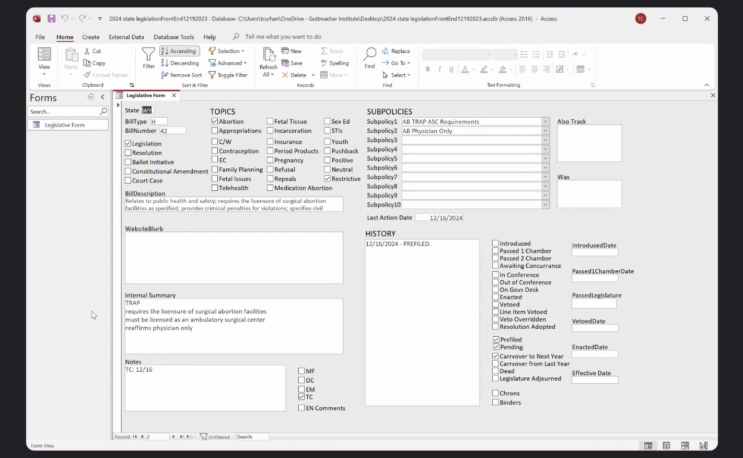
  - Could you show me exactly what happens between getting the Excel file and updating Access? What's most time-consuming there?
  - When you update records - what fields are you actually touching?
  - How long does a typical import usually take? When you say import, do you mean importing statenet files to access?
    - Import is the manual process of filling out the forms!
  - What makes some records trickier to update than others?
    - Some bills are thousands of words and some bills are a sentence, some bills
  - When you say tracked bills - what makes a bill tracked vs not?
    - Marking as tracked in statenet, so you get a changelog from the export
  - What's in Asana - just the imports or other tracking too?
    - The only thing that’s really in asana is “us” giving the web team the CSV file and sometimes mollie will put the export into asana – just for task management
    - The whole institute uses asana for communicating between divisions and within teams
  - Special Focus: Enacted Bills Report Process → ASK MOLLIE
    - Current Understanding:
      - Run "All Passed1 to Enact to Veto" query
      - Create two versions:
        - Full list for SiX
        - Abortion-only list for ACN/NAF
      - Distribute to multiple partners in batches
    - Questions About Reports
      - Is this Passed1 to Enact query something you run outside of the bi-monthly reports too?
      - Do you ever need to modify these exports for different audiences/requests?
      - Are there other regular exports like this that go to different partners?
      - Any challenges with the current report format/fields that we should know about?
- Workload Division
  - I see you're experimenting with splitting by topic - how's that going?
    - There are some number of topics, maybe 10-20 that they get emails about, mollie and talia just split that up.
    - Everything else is, pull the export from statenet from movement.
  - What's working/not working with the current task division in Asana?
  - Between StateNet email and final Access update - roughly how many days?
  - What takes longer - initial entry or bi-monthly updates?
- Quality Checks
  - Walk me through a typical scenario where you need to consult Kimya
  - What helps you catch potential issues before legal review?
  - How do you handle bills that touch multiple topics?
  - What helps you stay consistent between you and Mollie?
  - How do you track what Peter has edited?
  - How do you check if web updates worked correctly?
- Transition Concerns
  - What parts of the current process, despite being manual, really need to be preserved?
  - What would make the bi-monthly website updates easier?
  - Any concerns about moving away from Access?
  - Any thoughts on the rules/regs tracking gap?
    - They get just as many emails from statnet that includes regulations that contains bills. They track it on statenet either way, but don’t later.

Meeting Notes
- They review pre-filed bills
- 2025 database copies it all, and then deletes everything that doesn’t apply
- Important – GROUP BY STATE
- Policy / Subpolicy → is a creation of access, isn’t necessarily a valid organizing principle
- Positive, Neutral, Restrictive, Pushback → tags but are another cateogriy
- Krystal isn’t involved w tracking process
- Once we have the website view, Kimya will use legal experience to help with that
- Peter will do editing for website
- In asana, once there are bills that have been enacted, tasks
  - Website blurb
  - Peter from editing team → word document, blank, write the description – take from access – writing sentences for the twice a month emails – and then
  - Approval from approval
  - Then website

Action items
- tcurhan@guttmacher.org forwards Fryda lots of the statenet emails that are topic based that they receive
- Maybe fryda gets statenet login
- tcurhan@guttmacher.org writes some very basic plain language questions to ask the database as a check box for fryda

Dec 16, 2024 | Fryda / Liz
Attendees: liz.avore@gmail.com Fryda

Initial Project Scoping Meeting with Liz

Notes
- Need to get CSVs from Talia by tomorrow (two files)
- Airtable setup requirements:
  - Team Plan needed ($10/user/month, 5 users)
  - Need Guttmacher email from Lenny for base creation
- Stakeholder roles clarified:
  - Kimya - Policy expert, press communications, storytelling, external tracker
  - Talia - Legislation tracking with Mollie
  - Krystal - Senior state partnerships associate
  - Lenny - Annual Access database management
- Key investigation areas identified:
  - Access database annual creation process (Lenny)
  - Pre-filed bills handling (Talia)
  - External tracking needs (Kimya)
  - Partnership requirements (Krystal)
- Upcoming meetings scheduled:
  - Dec 18 - Talia (legislation tracking)
  - Dec 19 - Kimya (policy expertise)
  - Dec 20 - Krystal (partnerships)
- Office closure: Dec 24 (1pm) - Jan 1
Action Items
- Follow up with Talia for two CSV files
- Contact Lenny for Guttmacher email
- Set up Airtable Plan once email received
- Prepare for stakeholder meetings:
  - Review Talia questions re: pre-file process
  - Review Kimya questions re: external tracking
  - Review Krystal questions re: partnerships
- Document Access database requirements from Lenny

